Advanced Algebra 2 Name: _____________________
Unit 3 Quiz

Solve the following system of equations by any method.
- $–8x – 9y – 10z=–95$ $2x+2y+z=–84$ $–10x – 9y – 9z=11$

2. What is the solution to this resulting Answer Matrix?
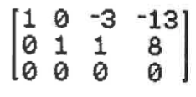
a. (-13,8,0)
b. No Solution
c. Infinitely Many Solutions
d. (1,0,0)

3. What is the solution to this resulting Answer Matrix?
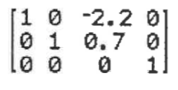
a. (-2.2,0.7,0)
b. No Solution
c. Infinitely Many Solutions
d. (0,0,1)

Write a system of equations and solve the system.
4. Three brothers are taking down a wooden fence. When all three brothers are working, they break down 16 feet of fencing per hour. When only the eldest and youngest brothers are working, they take down 10 feet per hour. The middle and youngest brothers manage to take down 8 feet per hour when working together. How much fencing can be taken down per hour by each brother?

